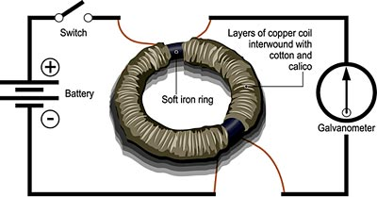

**To know what is possible.**

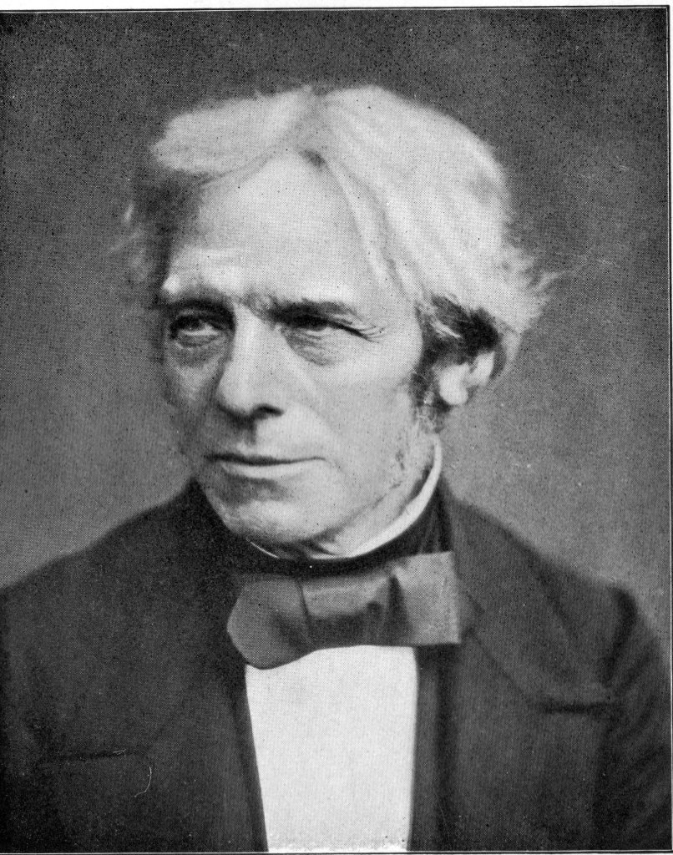

Michael Faraday

**(**[**Scientist**](https://en.wikipedia.org/wiki/Scientist) **on** [**electromagnetism**](https://en.wikipedia.org/wiki/Electromagnetism)**and**[**electrochemistry**](https://en.wikipedia.org/wiki/Electrochemistry)**, Sep 22, 1791 – Aug 25, 1867)**

An important thing is to know however quietly whether everything is understood.